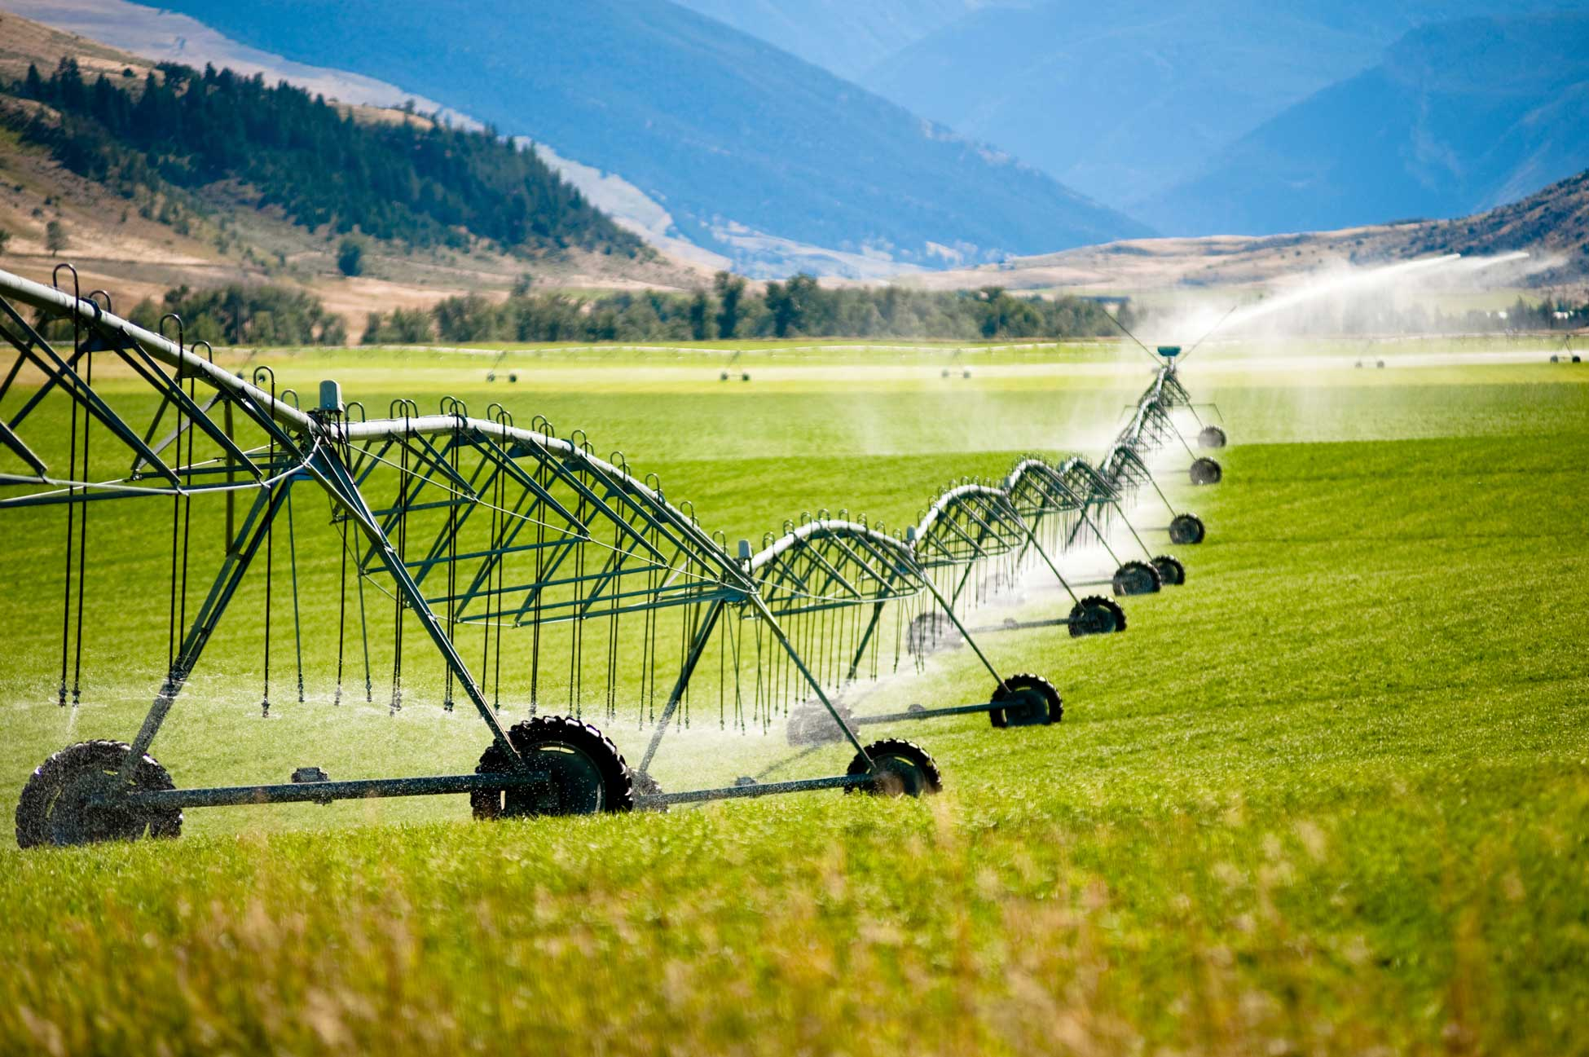

H.Integer Programming
Water Supply & Special Event Parking Optimization
Using the General Algebraic Modeling System
(GAMS)

Talha Quddoos- A02469393
Dr. David E. Rosenberg
CEE 6410- Civil Engineering Systems Analysis in the Age of Uncertainty
October 09, 2026

Part A.
Run Ex6-3-integer.gms available on GitHub. Answer the two questions:
- What GAMS statements declare and solve this problem as a mixed integer programming problem?
  - BINARY VARIABLES I: This statement declares the dimension variables I of the treatment plant and wholesale contract in the set src as binary serving as a step towards integer programming.
  - SOLVE WatSupplyRelaxed USING MIP MINIMIZING TCOST: MIP in this command tells GAMS that it is mixed integer problem.
  - The optimal minimized cost of water supply considering both the wholesale contract and the treatment plant came out to be $330,000. Total demand (2000 acf per year) is fully met by the treatment plant's available capacity, making it binding.
- What is the optimal solution and how did the branch and bound algorithm obtain the optimal solution?
  - The branch and bound method initially result in a relaxed value of $305,833 (Fig.1). To obtain the optimal solution, binary boundary conditions for the water contract were applied. 1) When the treatment plant is built instead of a water contract. 2) When a water contract is done instead of building a treatment plant. The initial condition (1) resulted in a minimized water supply cost of $330,000, while the later condition (2) resulted in a water supply cost of $335,000. The lower cost in condition 1 indicated that using water supply from the treatment plant gave us the minimal project cost, hence making it the optimal solution.

Part B.
Special Event Parking Planning problem
- Finish the model formulation that we started in class and submit.
- Complete the GAMS Code - here. This code already provides the input data.
- Summarize the optimal solution.
- Provide a link to your code on GIthub
The given problem had 2 dimensions (parking lots and vendors) and involved calculations for 2 decision variables (number of buses, number of grandstands). The objective function was to minimize the total event cost and the constraints were the total average travel time, bus seating capacity (all buses were required to operate when full) and maximum capacity of parking spaces.
The model resulted in the $9750 as the optimal cost to organize the event under given constraints with 7 buses from North, 9 buses from South and 8 buses from the West parking lot and Blue Sky as the optimal vendor for grandstands, providing 6 grandstands for the event. Maximum average travel time acted as binding in the model while the parking capacities were not binding. North parking lot used 350 parking spots, South used 450 and West parking lot used 400 parking spots.

Use of Artificial Intelligence (AI)
Claude AI was used to refresh and discuss the concepts https://claude.ai/share/05ce1e54-72f9-47be-b5c5-f2e354fee03f.

Github
https://github.com/talha-q/CEE6410-Engineering-Systems

References
GAMS Development Corporation. General Algebraic Modeling System (GAMS) Release: 54.4.0 , Fairfax, VA, USA, 2026 .

Appendix
Branch and Bound Method of Mixed Integer Programming
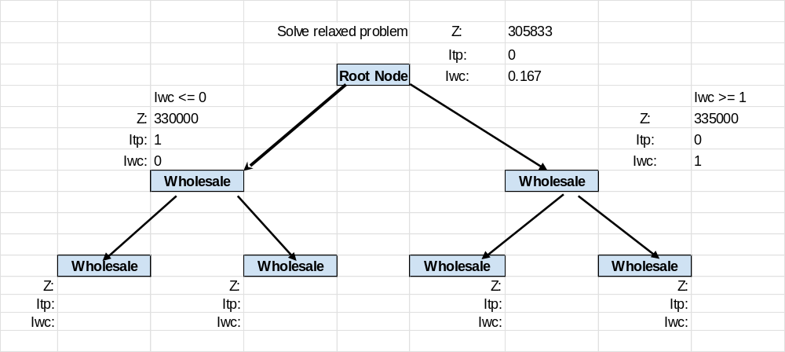
Figure 1 Branch and Bound Method for Water Supply Problem.

